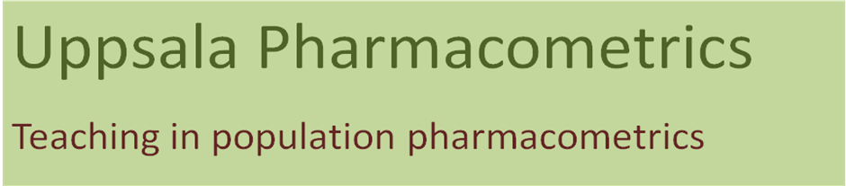

Pharmacokinetic-Pharmacodynamic modeling of continuous and categorical data in NONMEM 7
Berlin, Germany, June 6-8, 2010

Thank you for the interest in the course. Please complete the application form and return to Simonsson.ulrika@gmail.com. An invoice will be sent and your final registration will be made once the course fee is paid. The course fee has to be paid at least 2 weeks before the start of the course. You may contact us at Simonsson.ulrika@gmail.com if you have questions. We look forward to seeing you in Berlin.

Course Application Form
NAME*
AFFILIATION/COMPANY*
CONTACT ADDRESS*
TELEPHONE NUMBER
EMAIL ADDRESS*
INVOICE ADDRESS*
PURCHASE INVOICE NUMBER*
*Required

